**Experiment no- 01**

Name: Suraj P. Patil

Roll No: 3034

URN: 20131086

Class: TY(A)

Batch: T-2

**Title:**

*Installation procedure of StarUML.*

**Step 1-**

Visit the official website of the StarUML and click on the first link appeared on the screen.

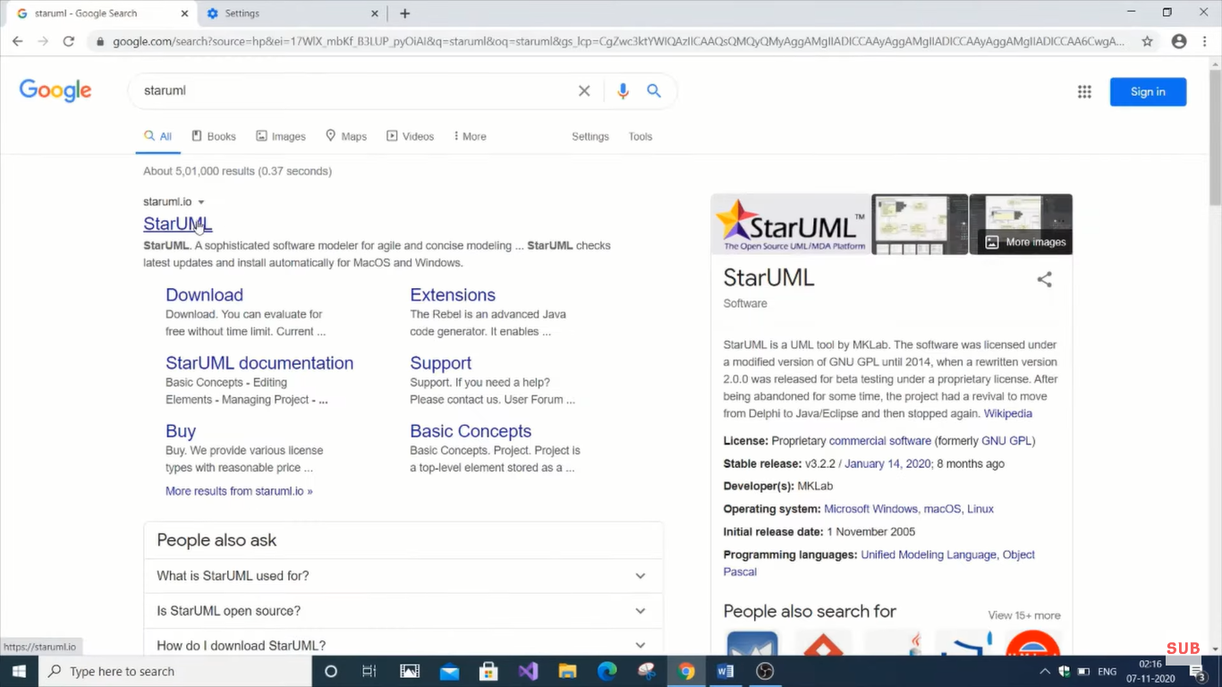

**Step 2-**

Click on the first link of the official website of the starUML and click on the Download for Windows option to the download the exe file of the StarUML.

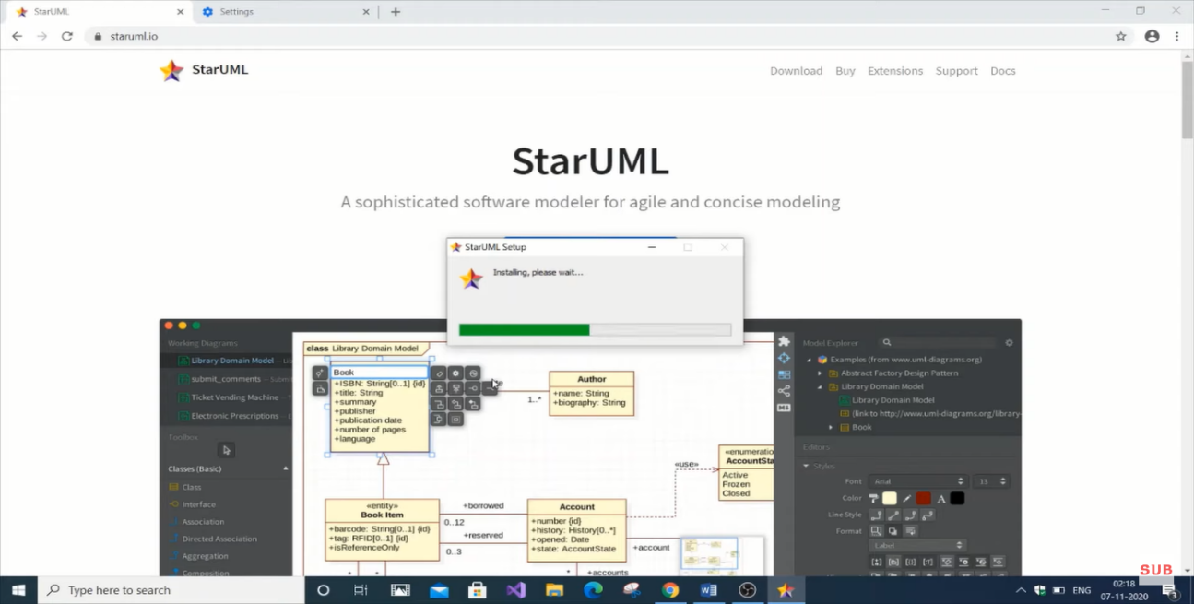

**Step 3-**

Click on the download for Windows option and download the .exe file of the StarUML and downloading the .exe file click on the downloaded file for the installation.

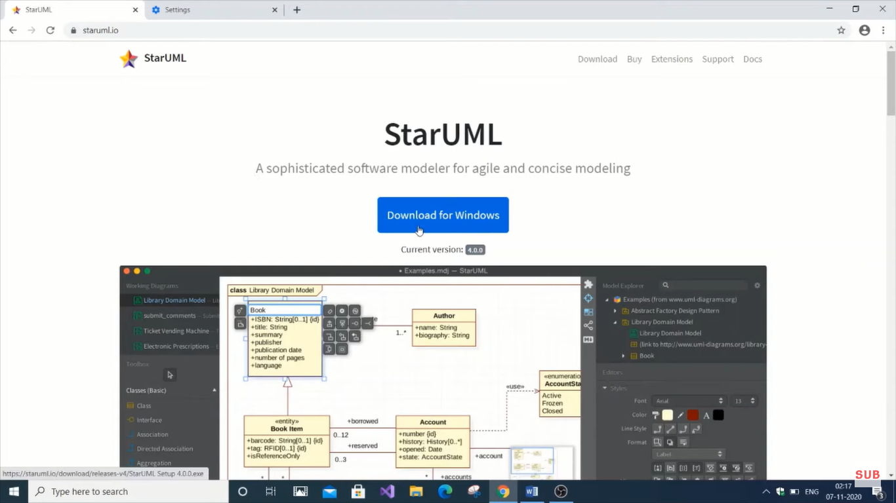

**Step 4-**

After installing the .exe file accept all the term and condition and click on the next to all the option and finally you will get the interface of the StarUML.

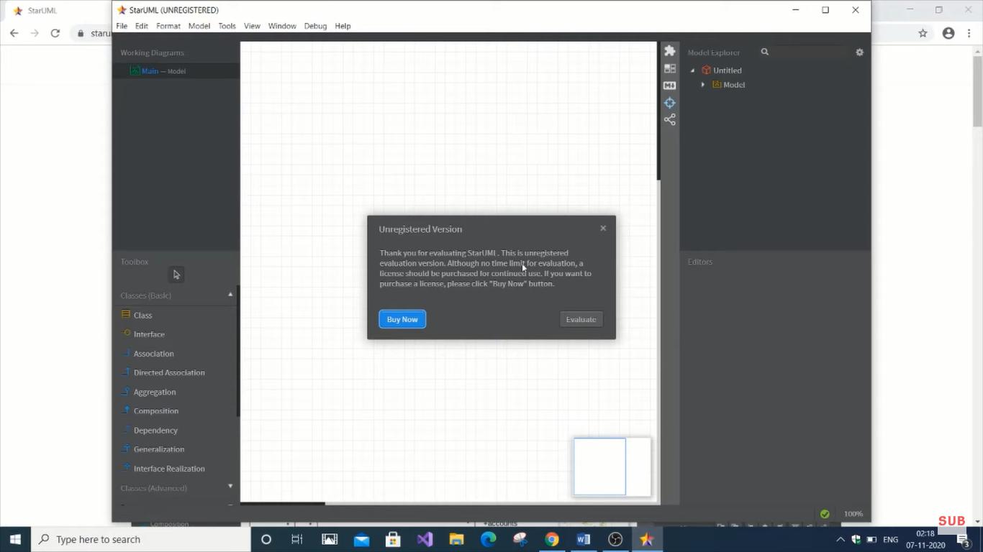

* **Introduction:**

StarUML is a software modeling tool used to create diagrams and models of software systems. It was first released in 2005 as a free and open-source UML modeling tool, but the project was abandoned by its original developers in 2011. In 2014, a group of developers launched a Kickstarter campaign to fund the development of a new version of StarUML, which was successfully funded. The new version of StarUML, called StarUML 2, was released in 2015 and included many new features and improvements.

* **Features:**
* StarUML is designed to be a flexible and extensible modeling tool that supports a wide range of modeling languages and standards, including UML, BPMN, SysML, ERD, DFD, and more. Some of the key features of StarUML include:
* UML 2.x standard-compliant diagrams and modeling tools
* Support for 11 different diagram types, including class diagrams, sequence diagrams, activity diagrams, and more
* Built-in code generation and reverse engineering capabilities for popular programming languages like Java, C++, and Python
* Customizable and extensible through the use of plugins and extensions
* Support for version control systems like Git and SVN
* **System Requirements:**

StarUML is available for Windows, macOS, and Linux operating systems. Here are the minimum system requirements for each platform:

*Windows:*

* Operating system: Windows 10, 8, 7, or Vista
* Processor: 1.6 GHz or higher
* Memory: 2 GB RAM or higher
* Hard disk space: 500 MB or more of free space

*macOS:*

* Operating system: macOS 10.13 or later
* Processor: 1.4 GHz or higher
* Memory: 2 GB RAM or higher
* Hard disk space: 500 MB or more of free space

*Linux:*

* Operating system: Ubuntu 18.04, Fedora 28, Debian 9 or later
* Processor: 1.6 GHz or higher
* Memory: 2 GB RAM or higher
* Hard disk space: 500 MB or more of free space

**Licensing:**

StarUML is available in two editions: Community Edition and Professional Edition. The Community Edition is free and open-source under the GPL 3.0 license. The Professional Edition is a commercial version that includes additional features and support. It is licensed on a per-user basis and requires a paid subscription.

**History:**

StarUML was initially created in 2005 by MKLab, a software development company based in Greece. The first version of StarUML was released as a free and open-source software under the GPL 2.0 license. The project was later abandoned by its original developers in 2011.

In 2014, a group of developers launched a Kickstarter campaign to fund the development of a new version of StarUML. The campaign was successfully funded, and development of StarUML 2 began shortly thereafter. The new version of StarUML was released in 2015 and included many new features and improvements.

**Conclusion:**

StarUML is a powerful and versatile modeling tool that can be used for a wide range of software development projects. Its support for multiple modeling languages and standards, as well as its customizable and extensible architecture, make it a popular choice among software developers and designers. Whether you're creating UML diagrams, BPMN diagrams, or ERD diagrams, StarUML provides the tools and features you need to create high-quality models of your software systems.